Turbo Props

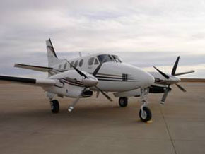 | King Air C90
  Passenger Capacity | 6-7 people
  Cruising Speed | 283 mph
  Range | 1267 st.m.
  Length | 12.7 ft.
  Width | 4.5 ft.
  Height | 4.8 ft.
  Baggage Capacity | 48 cu.ft.
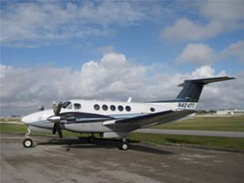 | King Air B200
  Passenger Capacity | 7-9 people
  Cruising Speed | 300 mph
  Range | 500 st.m.
  Length | 16.7 ft.
  Width | 4.5 ft.
  Height | 4.8 ft.
  Baggage Capacity | 55 cu.ft
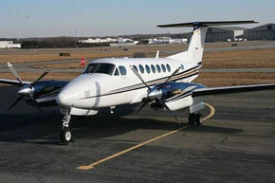 | King Air 350
  Passenger Capacity | 7-9 people
  Cruising Speed | 315 mph
  Range | 1700 st.m.
  Length | 16.8 ft.
  Width | 4.5 ft.
  Height | 4.1 ft.
  Baggage Capacity | 55 cu.ft.
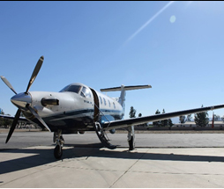 | Pilatus PC12
  Passenger Capacity | 8 people
  Cruising Speed | 310 mph
  Range | 1742 st.m.
  Length | 46 ft.
  Wing Span | 45 ft.
TURBO PROPS- All quotes by Vegas Express Jet include a Captain and First Officer. You will be pleased with the "Pricing for a Turbo Prop Aircraft" and benefit from up to 7 seats.
- Turbo Props some flights may be slightly longer. A Trips from John Wayne (SNA) airport takes only 10 minutes longer to Las Vegas----your cost savings are up to 20%. A sample price for a Las Vegas Weekend is $7,000 for the charter plus 15% for the federal Taxes, Landing fees and upcharges for credit card and handling fees.
- Comfort is not an issue, lower prices make the turbo prop a great value
- The turbo prop is a great option for airports with very limited runways
- The costs for the Premier Pilatus aircraft are generally higher when compared to the new light jets--this relates to the purchase price of this Jet which is $7-. Build in Switzerland the Pilatus is amongst the most desired Turbo Props. This aircraft is only available at the Ontario CA airport.
Hourly charter costs range from $2500- to $3000- per hour.
Do consider the following option for your next journey:
The newest group of Very Light Jets offer very attractive hourly charter rates and the comforts of a Luxury Jet at no additional charge:
- The Phenom 100 designed by Embraer offers seating for 4 passengers and an interior designed by BMW with luxury swivel seats
- Rates for the Phenom start from $2,000 per hour. You benefit from the a higher speed at 390MPH.
- You will have ample room for baggage on the Phenom 100
- With over 300 aircraft in the air the Phenom provide the comfort and benefits of a much larger jet, an excellent choice at a very affordable rate.
- Ask for a rate quote our call our airport desk at p.702.336-7345
Feel free to complete a rate quote request and benefit from a Complimentary Limousine Transfer on the Las Vegas Strip
Good to know: Over 80% of all the Private Jet Charter trips are under 1,000 miles. No need to upgrade to a large jet with too many seats. Conserve fuel and fly safe.
Text Block

King Air C90
Passenger Capacity | 6-7 people
Cruising Speed | 283 mph
Range | 1267 st.m.
Length | 12.7 ft.
Width | 4.5 ft.
Height | 4.8 ft.
Baggage Capacity | 48 cu.ft.

King Air B200
Passenger Capacity | 7-9 people
Cruising Speed | 300 mph
Range | 500 st.m.
Length | 16.7 ft.
Width | 4.5 ft.
Height | 4.8 ft.
Baggage Capacity | 55 cu.ft

King Air 350
Passenger Capacity | 7-9 people
Cruising Speed | 315 mph
Range | 1700 st.m.
Length | 16.8 ft.
Width | 4.5 ft.
Height | 4.1 ft.
Baggage Capacity | 55 cu.ft.

Pilatus PC12
Passenger Capacity | 8 people
Cruising Speed | 310 mph
Range | 1742 st.m.
Length | 46 ft.
Wing Span | 45 ft.

TURBO PROPS- All quotes by Vegas Express Jet include a Captain and First Officer. You will be pleased with the "Pricing for a Turbo Prop Aircraft" and benefit from up to 7 seats.
- Turbo Props some flights may be slightly longer. A Trips from John Wayne (SNA) airport takes only 10 minutes longer to Las Vegas----your cost savings are up to 20%. A sample price for a Las Vegas Weekend is $7,000 for the charter plus 15% for the federal Taxes, Landing fees and upcharges for credit card and handling fees.
- Comfort is not an issue, lower prices make the turbo prop a great value
- The turbo prop is a great option for airports with very limited runways
- The costs for the Premier Pilatus aircraft are generally higher when compared to the new light jets--this relates to the purchase price of this Jet which is $7-. Build in Switzerland the Pilatus is amongst the most desired Turbo Props. This aircraft is only available at the Ontario CA airport.
Hourly charter costs range from $2500- to $3000- per hour.
Do consider the following option for your next journey:
The newest group of Very Light Jets offer very attractive hourly charter rates and the comforts of a Luxury Jet at no additional charge:
- The Phenom 100 designed by Embraer offers seating for 4 passengers and an interior designed by BMW with luxury swivel seats
- Rates for the Phenom start from $2,000 per hour. You benefit from the a higher speed at 390MPH.
- You will have ample room for baggage on the Phenom 100
- With over 300 aircraft in the air the Phenom provide the comfort and benefits of a much larger jet, an excellent choice at a very affordable rate.
- Ask for a rate quote our call our airport desk at p.702.336-7345
Feel free to complete a rate quote request and benefit from a Complimentary Limousine Transfer on the Las Vegas Strip
Good to know: Over 80% of all the Private Jet Charter trips are under 1,000 miles. No need to upgrade to a large jet with too many seats. Conserve fuel and fly safe.

Theme Settings
Move upMove downToggle panel: Theme Settings
- Main
- Header
- Title
- Slider
- Background
- Footer
- Callout
Redirect
Enter a URL to redirect this post or page.
Site Layout
This option should only be used in very specific cases since there is a global setting available in the Customizer.
Content Layout
Select your custom layout for this page or post content.
Dynamic Template
Select a dynamic templatera template to override this page. If selected it will disable the front-end editor.
Sidebar
Select your a custom sidebar for this page or post.
Toggle Bar
Enable or disable this element on this page or post.
Top Bar
Enable or disable this element on this page or post.
Breadcrumbs
Enable or disable this element on this page or post.

